Name ______________________ Date ___________________

**LE Exam 1**

*Directions* (1–30): For *each* statement or question, record on your separate answer sheet the *number* of the word or expression that, of those given, best completes the statement or answers the question.

1. The chart below summarizes the effect of commercial fishing on a local Atlantic cod population over a 9-year period.

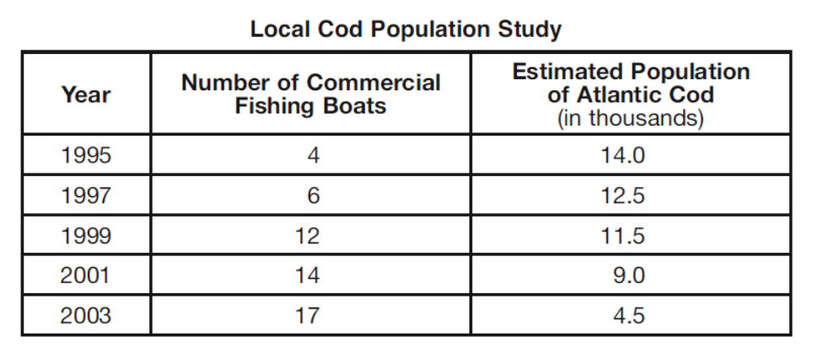

According to the chart, it can be concluded that

(1) the number of fishing boats has less effect on the local cod population than pollution

(2) more fishing boats make the cod population estimates more accurate

(3) an increase in fishing boats has had a positive impact on cod population growth

(4) commercial fishing is having a negative effect on the local cod population

|  |  |
| --- | --- |
| A student is opening and closing clothespins  as part of a lab activity. The student begins  to experience muscle fatigue, and the rate at  which the student is opening and closing the  clothespins slows.  2. The fatigue is due to  (1) an increase of metabolic waste products in  the muscles  (2) an increase in the pulse rate of the student  (3) a decrease of metabolic waste products in the muscles  (4) a decrease in the pulse rate of the student  3. In order for the muscle fatigue to end, the  muscle cells must be provided with  (1) oxygen (3) carbon dioxide  (2) nitrogen (4) amino acids | 4. A student hypothesized that watching sports on television would cause viewers’ pulse rates to increase. She designed an experiment to determine the effect of watching sports on pulse rate. A group of 200 volunteers took their pulse rates and then watched their favorite sports on television. After the games, they immediately took their pulse rates again. The data collected showed that the pulse rates of some people increased, but the pulse rates of an equal number of people did not change. Although the hypothesis was not supported by the data, the hypothesis is still valuable because it  (1) may lead to further investigation  (2) is the opinion of the experimenter  (3) can be changed to fit the data  (4) is based on beliefs of the volunteers |

*Base your answers to questions 5 through 7 on the information and graph below and on your knowledge of biology.*

Students were asked to design a lab that investigated the relationship between exercise and heart rate. Heart rate was determined by recording the pulse rate in beats per minute. The students hypothesized that increased exercise results in an increased heart rate. The class results for the experiment are shown in the graph below.



5. Which statement is best supported by the graph?

(1) Before exercising, the average pulse rate was 65; four minutes after exercising, the average pulse rate was 65.

(2) After four minutes of exercising, the average pulse rate was 120; two minutes after exercising, the average pulse rate was 120.

(3) While exercising, the highest average pulse rate was 150; before exercising, the average pulse rate was 65.

(4) Two minutes before exercising, the average pulse rate was 80; after two minutes of exercise, the average pulse rate was 140.

6. Students in a different science class carried out the same experiment. The data they obtained did *not* support the hypothesis that increased exercise results in increased heart rate. The most scientifically soundway to deal with this situation is to

(1) write a new hypothesis

(2) read about pulse rate in a biology textbook

(3) have the students in both classes vote to decide which hypothesis is correct

(4) ask students in a third class to do the experiment and see if their results support the hypothesis

7. The change in heart rate that occurs between 1 and 5 minutes of exercise is an adaptation that

(1) reduces the rate at which oxygen is carried to the muscle cells

(2) increases the rate at which carbon dioxide is carried to the muscle cells

(3) results in the production of more ATP in muscle cells

(4) slows the destruction of enzymes involved in respiration of muscle cells

8. The dichotomous key below provides a way to classify some animals into groups according to their physical characteristics.



The key can be used to classify each of the four animals represented below.



Which row in the chart shows the correct classification group for each animal?



9. In an experiment to determine the effect of exercise on pulse rate, a student checks his pulse rate before and after exercising for several minutes. The purpose of checking his pulse rate before exercising is that it

(1) serves as the conclusion for the experiment

(2) is needed to justify the sample size

(3) serves as a control for the experiment

(4) is needed to formulate a hypothesis

*Base your answers to questions 10 through 12 on the information below and on your knowledge of biology.*

An experiment was carried out to answer the question “Does the pH of water affect the growth of radish plants?” Two groups of ten radish plants were set up. One group was watered with water having a pH of 3.0, and the other group was watered with water having a pH of 7.0. Both groups of plants received the same amount and intensity of light, the same amount of water, and they were grown in the same type of soil. The heights of the radish plants were measured every 2 days for a period of 2 weeks.

10. Which sentence is a possible hypothesis that was tested in this experiment?

(1) Does the pH of water affect the growth of radish plants?

(2) Will the amount of water alter the heights of the radish plants?

(3) The temperature of the water will affect the heights of the radish plants.

(4) The pH of the water will affect the heights of the radish plants.

11. What was the dependent variable in this experiment?

(1) heights of the plants (3) temperature of the water

(2) pH of the water (4) type of soil

12. Which activity might help to increase the validity of this experiment?

(1) repeating the experiment several times

(2) using two different types of radish seeds in each group

(3) using the same pH for both groups of plants

(4) placing one set of plants in sunlight and one in darkness

13. What is an advantage of a change in pulse rate after exercising?

(1) The heart needs to produce more energy to supply the active muscle cells and maintain homeostasis.

(2) An increased blood flow carries excess waste products away from the active muscle cells.

(3) The blood is removing oxygen from muscle cells that were not active and carrying it to muscle cells that are active.

(4) The blood is supplying the active muscle cells with carbon dioxide to neutralize wastes in those cells.

14. To determine the effect of fatigue on the action of muscles, each of five boys was given a 12-cm clothespin and each of five girls was given a 10-cm clothespin. The students squeezed the clothespins for 30 seconds and recorded the results. After the first trial, the girls rested and the boys jogged in place for 1 minute. A second trial was then done to determine how many times each student could squeeze the clothespin in 45 seconds. Identify *one* error in the design of this experiment. [1]

*Base your answers to questions 15 on the passage below and on your knowledge of biology.*

**Smoking is Dumb**

A study by Prof. Mark Weiner of Tel Aviv University’s Department of Psychiatry and the

Sheba Medical Center of Tel Hashomer Hospital has determined that young men who smoke are likely to have lower IQs than their nonsmoking peers. Tracking 18- to 21-yearold men enlisted in the Israeli army in the largest study of its kind, he has been able to demonstrate an important connection between the number of cigarettes young males smoke and their IQ. The average IQ for a nonsmoker was about 101, while the smokers’ average was more than seven IQ points lower at about 94, the study determined. The IQs of young men who smoked more than a pack a day were lower still, at about 90. An IQ score in a healthy population of such young men, with no mental disorders, falls within the range of 84 to 116.

Source: *Science Daily* April 2, 2010

15. Based on the information given in the passage, state the relationship between the number of cigarettes young males smoke and their IQ. [1]

*Base your answers to questions 16 and 17 on the information below and on your knowledge of biology.*

Three students took their pulse rates in beats per minute (bpm) while sitting in class.

The results are shown in the data table below.



16. State *one* reason why the pulse rates were *not* the same for all three students, even though they were all resting at the time. [1]

17. What is the average pulse rate, in bpm, for this group of students? [1]

**________________ bpm**

*Base your answers to question 18 on the information below and on your knowledge of biology.*

Ticks, such as deer ticks and dog ticks, feed on the blood of humans and other animals.

Part of the feeding process involves the tick injecting its saliva to help make blood flow.

In the process, they sometimes spread disease organisms to their host. Sometimes ticks get on clothing, and can remain there for a few days before actually biting their host.

A scientist found that ticks might be able to survive even when exposed to hot water and detergent in a washing machine.

Students designed the experiment below to test how well ticks survive a hot-water washing machine cycle with detergent. Note that some details of the design are incorrect.



18. Identify *one* error in the students’ design in the shaded area of the table and explain how the students should change the experiment to correct the error. [1]



D*irections* (19-20): Using the information given in the data table, construct a line graph on the grid following the directions below.

19. Mark an appropriate scale, without any breaks, on the axis labeled “Concentration of Estrogen.” [1]

20. Plot the data for concentration of estrogen on the grid. Surround each point with a small circle and connect the points. [1]

Name __________________________________

LE test 1

1. 8. __________
2. 9. __________
3. 10. __________
4. 11. __________
5. 12. __________
6. 13. __________
7. 14. __________

14. __________________________________________________________________

__________________________________________________________________

15. __________________________________________________________________

__________________________________________________________________

__________________________________________________________________

16. ___________________________________________________________________

___________________________________________________________________

___________________________________________________________________

17. _________bpm

18. ___________________________________________________________________

___________________________________________________________________

19-20

